P530/2
Biology
Paper 2
July 2018
2½ Hours

UGANDA ADVANCED CERTIFICATE OF EDUCATION
BIOLOGY
Paper: P530/2
Time: 2 Hours 30 Minutes

Instructions to candidates

This paper consists of Sections A and B.
Answer question one in Section A plus any three others from Section B.
Candidates are advised to read the questions carefully, organize their answers and present them precisely and logically, illustrating with well labeled diagrams wherever necessary.

For Examiners’ use only
Question number attempted | Number | Score | Signature/initials
Section A: | 1
Section B:
Total

SECTION A: (40 MARKS)
- In an experiment to study the effectiveness of DDT towards the cabbage pest, Pieris rapae
which feeds on cabbage leaves, two adjacent farm yards where prepared and Pieris was
introduced in each farm and left for some time. After spraying one farm yard with DDT for three consecutive times, the number of eggs that survived and hatched into larvae at the sprayed and non sprayed farm yards was determined as shown by Graph A .
In another set of experiment, Pieris rapae was exposed to birds as its control agents and the changes in the population of both, with time was determined as indicated by Graph B . Study the graphs and answer the questions that follow
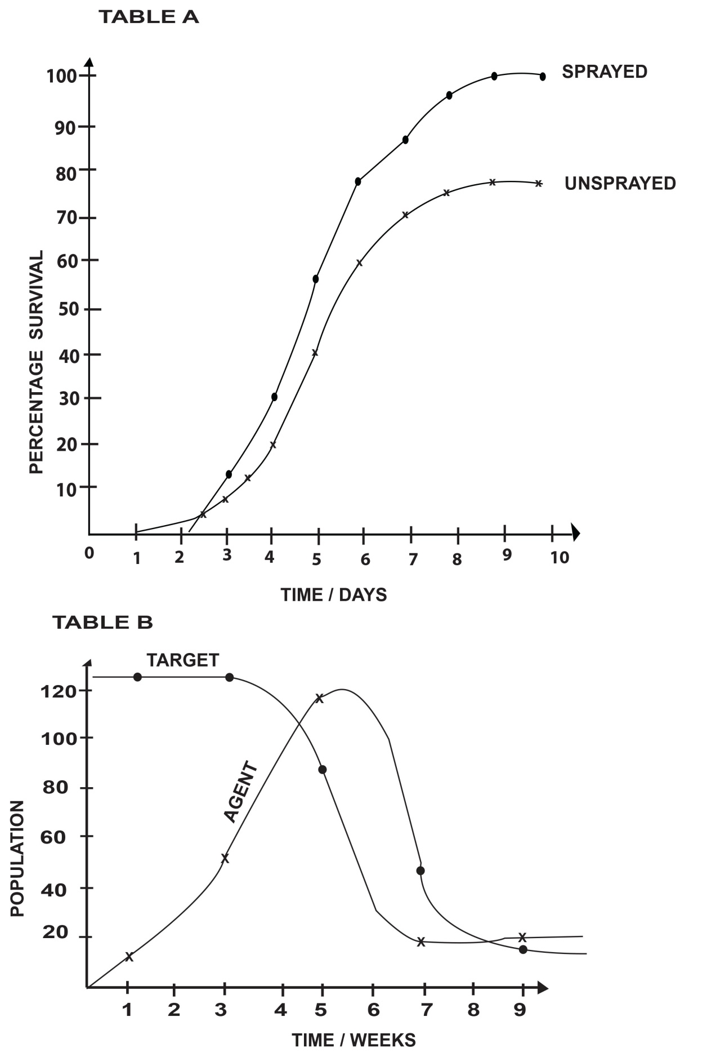

0

- i) Account for the increase in the population of the control agent (05 marks)
- Explain the decrease in the population of the control agent (05 marks)
- i) Account for the decrease in the population of Pieris rapae (05 marks)
- Account for the population of Pieris and that of the control agent from 8½ to the 9th week
(04 marks)
- Compare the number of eggs of Pieris between the sprayed and non sprayed farm yards
(05 marks)
- Account for the differences in the number of eggs of Pieris at the sprayed and non-sprayed farm yards (08 marks)
- Explain any one property of DDT other than the one shown above, which render it unsuitable for environmental use (05 marks)
- Outline any three advantages of the method used in Graph B to that used in Graph A.
(03 marks)

SECTION B (60 MARKS)

- (a) Explain the post-natal changes in the human embryo. (10 marks)
(b) What is the significance of the changes mentioned in 2(a) above? (05 marks)
(c) How is the mammalian placenta adapted for the transportation role? (05 marks)

- (a) Describe how food ingestion stimulates larval development into an adult grasshopper. (12 marks)
(b) Explain the significance of neuro-secretion in man. (08 marks)

- (a) Describe the chemiosmotic synthesis of energy within the chloroplasts. (12 marks)
(b) Compare the chemiosmotic synthesis of energy described in 4(a) above with that in the mitochondria. (08 marks)

- (a) Explain phototropism in plants. (10 marks)
(b) What is the significance of tropisms towards plant diversity? (10 marks)

- (a) Derive the Hardy-Weinberg equation from first principles. (10 marks)
(b) Describe how:
i) Random mating
ii) Genetic drift, affect the allele frequency of a sexually reproducing population.
(10 marks)

⋆⋆⋆⋆End⋆⋆⋆⋆

